Nama : Sidna Muhammad Zen

NIM : 18090144

Kelas : 5B

PRAKTIKUM 2

1. Source Code

latihan1-> application/controller

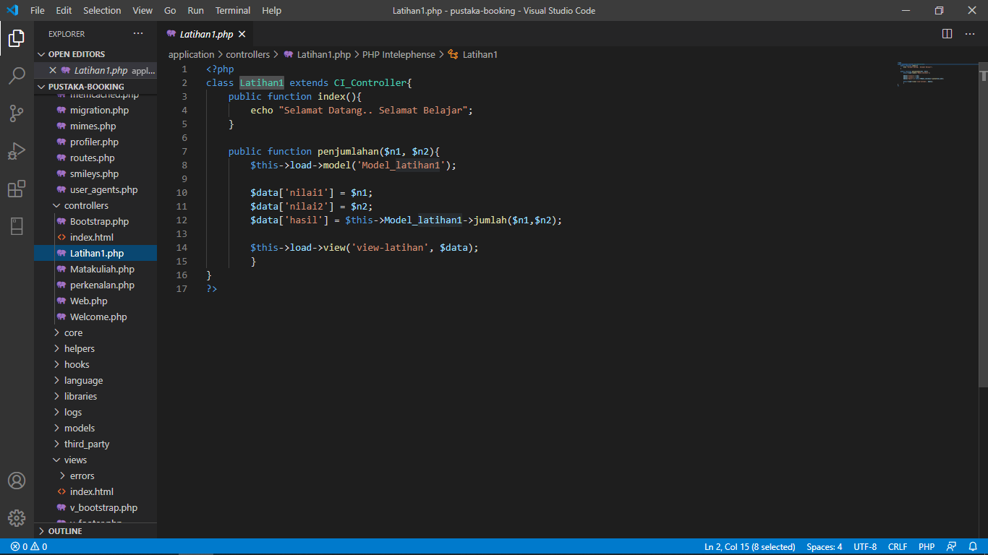

Model_latihan1 -> application/models

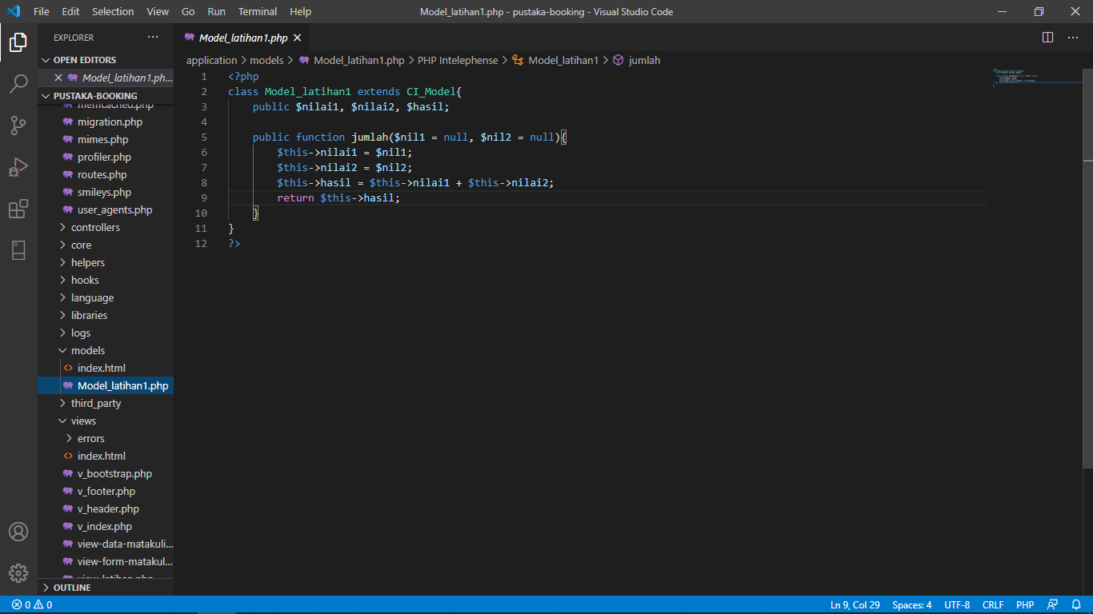

View_latihan -> application/view

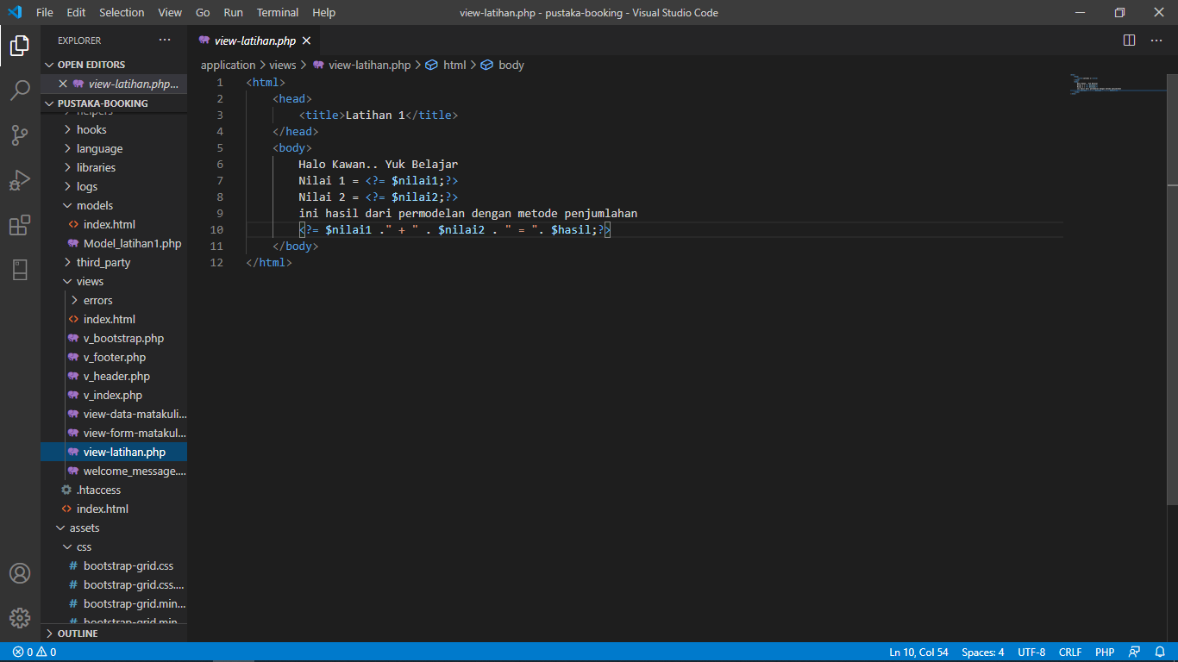

1. URL

[http://localhost/pustaka](http://localhost/pustaka_haniff/index.php/latihan2)-booking/latihan1

[http://localhost/pustaka](http://localhost/pustaka_haniff/index.php/latihan2)-booking/latihan1/penjumlahan/2/3

1. Capture Hasil

**Hasil run latihan1**

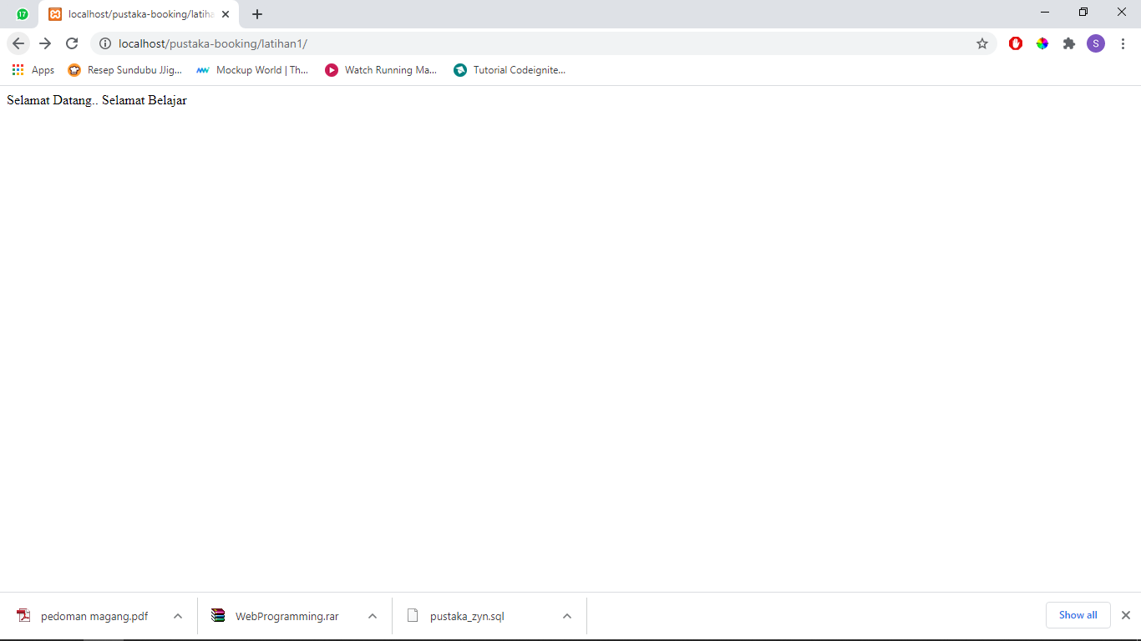

**Hasil run penjumlahan**

